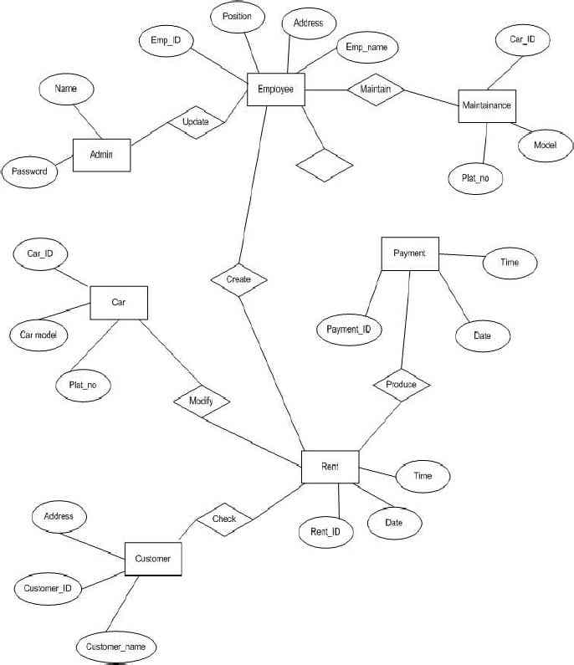**E-R DIAGRAM FOR Car-Rental-Website**

The entity relationship diagram describes the relationship between entities, cardinality and their attributes. Entity–relationship model (ER model) is a data model for describing the data or information aspects of a business domain or its process requirements, in an abstract way that lends itself to ultimately being implemented in a database such as a relational database. The main components of ER models are entities (things) and the relationships that can exist among them. In here we provide a description of entities with all their attributes. Describing entity name, business definition for the entities and there attribute and domain.

**Entity Description:-**

|  |  |
| --- | --- |
| **Entity Name** | **Business definition** |
| Employee | This entity is responsible to store Employee information in the database. |
| Customer | Attribute stores customers’ details information in the database, in order to identify the customer. |
| Car | This entity is stores the information of the vehicle in the database. |
| Reservation | This stores information about the reservations made by a customer. |
| Rent | This stores rental information of the vehicle, payments |
| Maintenance | This checks for repairing and replacing. |
| Payment | This produce payment and rent the car. |